World Antimicrobial Awareness Week Campaign - Social Media & Graphics content pack

Below we have outlined some sample posts that can be posted from your Practice/Pharmacy’s public-facing social pages, such as Facebook and X (formally known as Twitter).

These messages can be posted from the launch of the WAAW 2024 campaign on Saturday 18th November.

Please ensure when posting the content you include a link to the campaign website (seriouslyresistant.com) and include the alt-tag for images to ensure accessibility for all patients.

Topic | Recommended visual | Copy | Image alt tag
Prevention | West Yorkshire: Its time to take Seriously Static Image  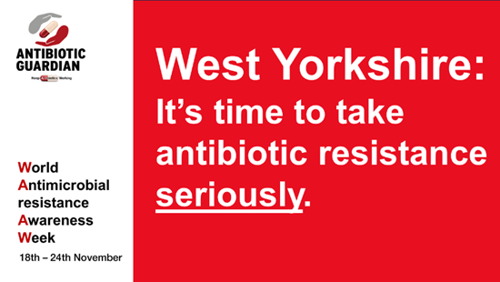 | West Yorkshire  18th November marks the start of World Antimicrobial Awareness Week. Find out why we all need to take antibiotic resistance seriously at seriouslyresistant.com.  #KeepAntibioticsWorking  #WAAW2024 #EAAD  #TakeAntibioticsSeriously | Image reads West Yorkshire. It’s time to take antibiotic resistance seriously.  The website address is www.seriouslyresistant.com
Antibiotic use behaviour | ‘Don’t share with friends or family’ animated graphic (mp4 file)  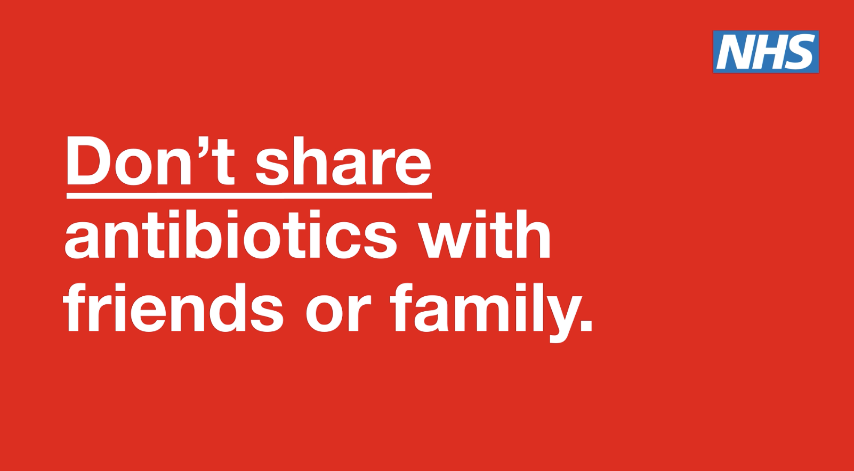 | Antibiotics are prescribed to different people for different reasons, even if symptoms might be similar. Using old antibiotics or sharing them could mean delaying effective treatment, make you or your family member sicker and even cause side effects.  seriouslyresistant.com  #AntimicrobialResistance  #KeepAntibioticsWorking  #WAAW2024  #TakeAntibioticsSeriously | Image reads ‘Don’t share antibiotics with friends or family. Antibiotics to treat your infection may not be able to help your friend or family member.’  The website address is www.seriouslyresistant.com  Hashtag Take Antibiotics Seriously.
Education/ common illness | ‘Antibiotics treat bacteria, not viruses’ animated graphic (mp4 file)  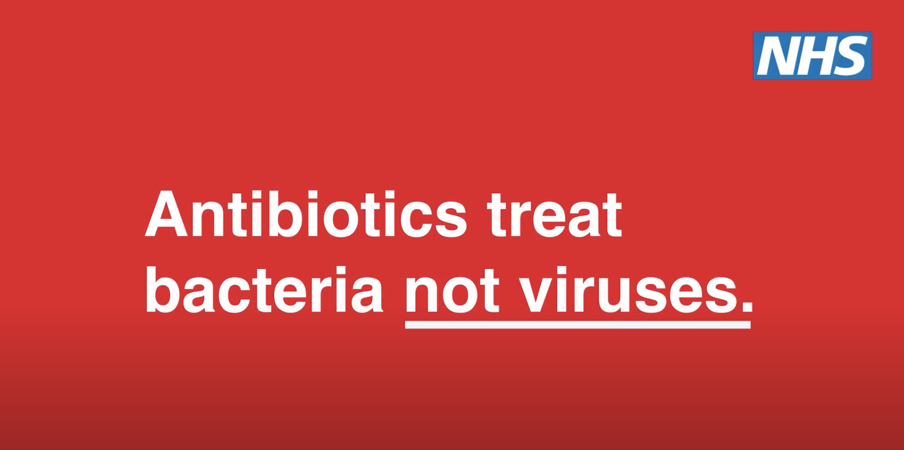 | Most common illnesses like coughs, colds and sore throats are caused by viruses. Viral infections cannot be treated with antibiotics.  Visit seriouslyresistant.com for more information on how to treat common infections  #AntimicrobialResistance  #KeepAntibioticsWorking  #WAAW2024  #TakeAntibioticsSeriously | Image reads ‘Antibiotics treat bacteria not viruses’.  The website address is www.seriouslyresistant.com  Hashtag Take Antibiotics Seriously.
Education/ common illness | ‘Antibiotics won’t treat colds’ animated graphic (mp4 file)  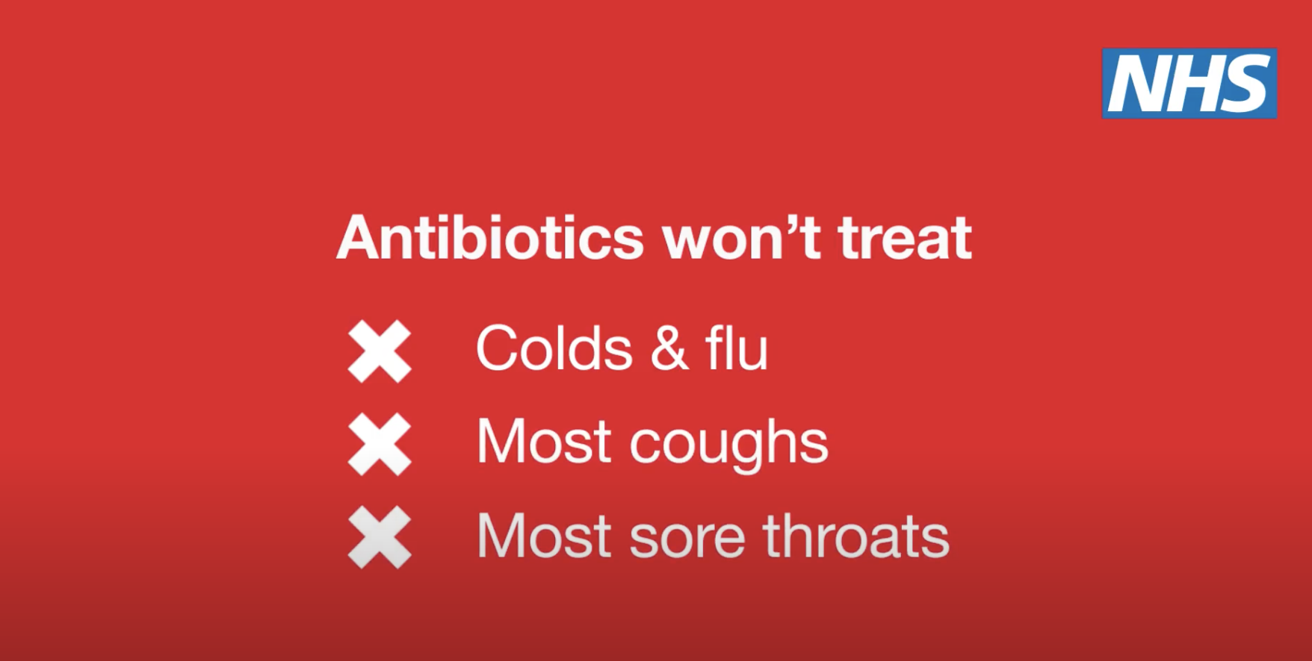 | Antibiotics are used to treat serious bacterial infections. Many mild infections, including those caused by viruses such as cold and flu, can get better on their own without antibiotics.  Visit seriouslyresistant.com for more information on how to treat common infections  #AntimicrobialResistance  #KeepAntibioticsWorking  #WAAW2024  #TakeAntibioticsSeriously | Image reads ‘Antibiotics won’t treat colds and flu, most coughs, most sore throats.’  The website address is www.seriouslyresistant.com  Hashtag Take Antibiotics Seriously.
Education/ antibiotic resistance | ‘Only take them when you really need them’ static graphic  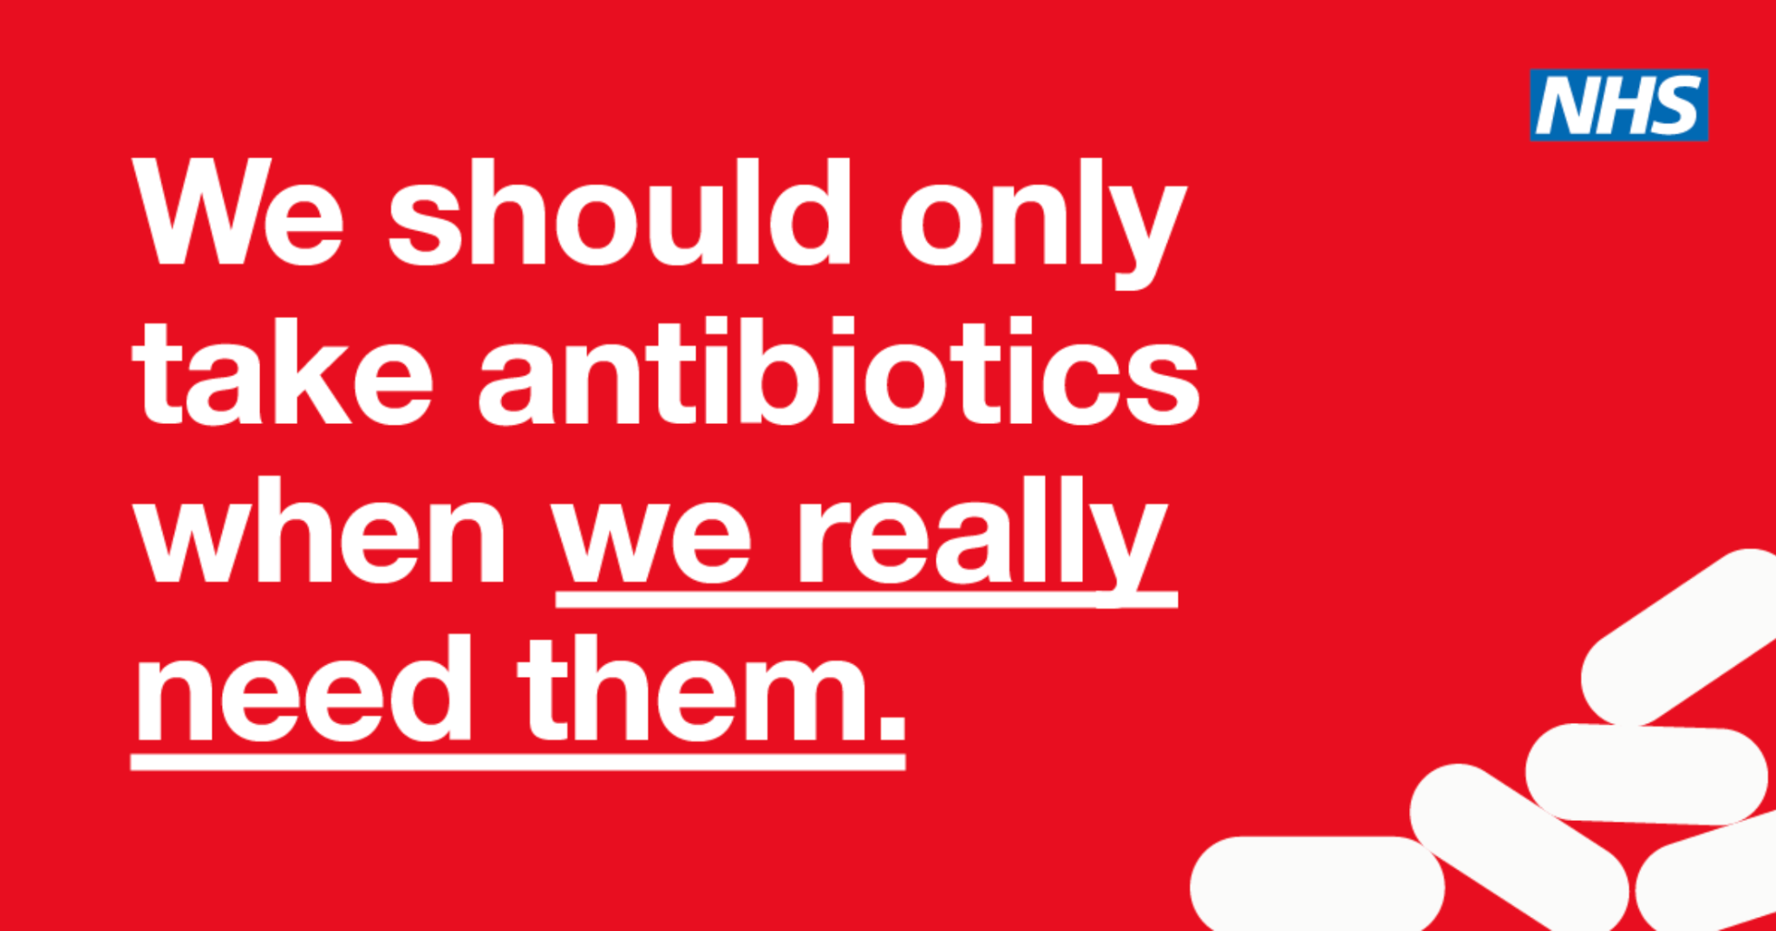 | Antibiotic resistance is when germs like bacteria can defeat the antibiotics designed to kill them. The overuse of antibiotics has made them less effective. Only use antibiotics as prescribed by a healthcare professional.  For more information visit seriouslyresistant.com  #AntimicrobialResistance  #KeepAntibioticsWorking  #WAAW2024  #TakeAntibioticsSeriously | Image reads ‘we should only take antibiotics when we really need them’.
Education/ common illness (sore throat) | ‘Sore throat, with a cough?’ animated graphic (mp4 file)   | Most sore throats are caused by viruses and should improve within a week.  Antibiotics won’t treat a virus but there are other things which can help.  Visit seriouslyresistant.com/common-infections for more information on how to treat common infections  #AntimicrobialResistance  #KeepAntibioticsWorking  #WAAW2024  #TakeAntibioticsSeriously | Image reads ‘Sore throat, with a cough? Most likely a virus. Antibiotics won’t treat a virus.’
Education/ common illness (cold) | Treatment isn’t always antibiotics animated graphic (MP4 file or static file)  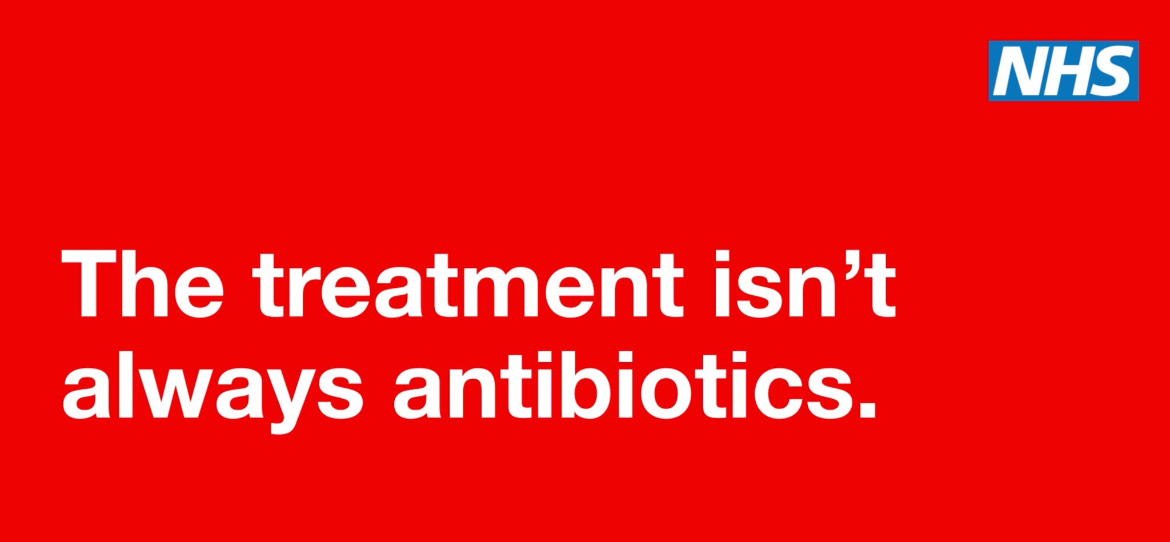 | More than 200 viruses can cause a cold with some more common than others.  Antibiotics won’t help you get better if you have a cold. You should begin to feel better in about 1 to 2 weeks.  Visit seriouslyresistant.com for more information on how to treat common infections  #AntimicrobialResistance  #KeepAntibioticsWorking  #WAAW2024  #TakeAntibioticsSeriously | Image reads ‘The treatment isn’t always antibiotics. Join the Seriously movement to keep antibiotics working.’  The website address is www.seriouslyresistant.com  Hashtag Take Antibiotics Seriously.
Education/ common illness (chest infection) | Treatment isn’t always antibiotics animated graphic (MP4 file or static file) | Have a suspected chest infection? Antibiotics are only used to treat bacterial chest infections. They're not used for treating viral chest infections, like flu or viral bronchitis.  Any prescribed treatment will depend on what’s causing your infection. Speak to your healthcare professional who will advise on the right treatment at the right time for you.  #AntimicrobialResistance  #KeepAntibioticsWorking  #WAAW2024  #TakeAntibioticsSeriously | Image reads ‘The treatment isn’t always antibiotics’.
Education/ common illness (general) | Treatment isn’t always antibiotics animated graphic (MP4 file or static file) | Most common infections don’t get better any quicker with antibiotics.  In many cases, your immune system will do a better job of clearing the infection without the need for additional treatment.  Visit seriouslyresistant.com/common-infections for more information on how to treat common infections  Or speak to your healthcare professional who will advise on the right treatment at the right time for you.  #AntimicrobialResistance  #KeepAntibioticsWorking  #WAAW2024  #TakeAntibioticsSeriously | Image reads ‘The treatment isn’t always antibiotics’.
Education/ Environmental Impact | Antibiotic Amnesty - static graphic  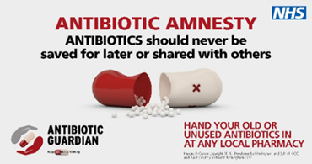 | Protect Your Environment & Minimise Pollution  Never flush unused or expired antibiotics medicine down the drain.  If you have received more doses than you were prescribed, ask your pharmacist about how to dispose of the remaining medicines.  https://seriouslyresistant.com  #AntibioticGuardian  #KeepAntibioticsWorking  #WAAW2024  #TakeAntibioticsSeriously | Image reads Antibiotic Amnesty. Antibiotics should never be saved for later or shared with others. Hand your old or unused antibiotics in at any local pharmacy. Antibiotic Guardian. Keep antibiotics working.

