# Improving Population Health Fellowship

# Statement of interest

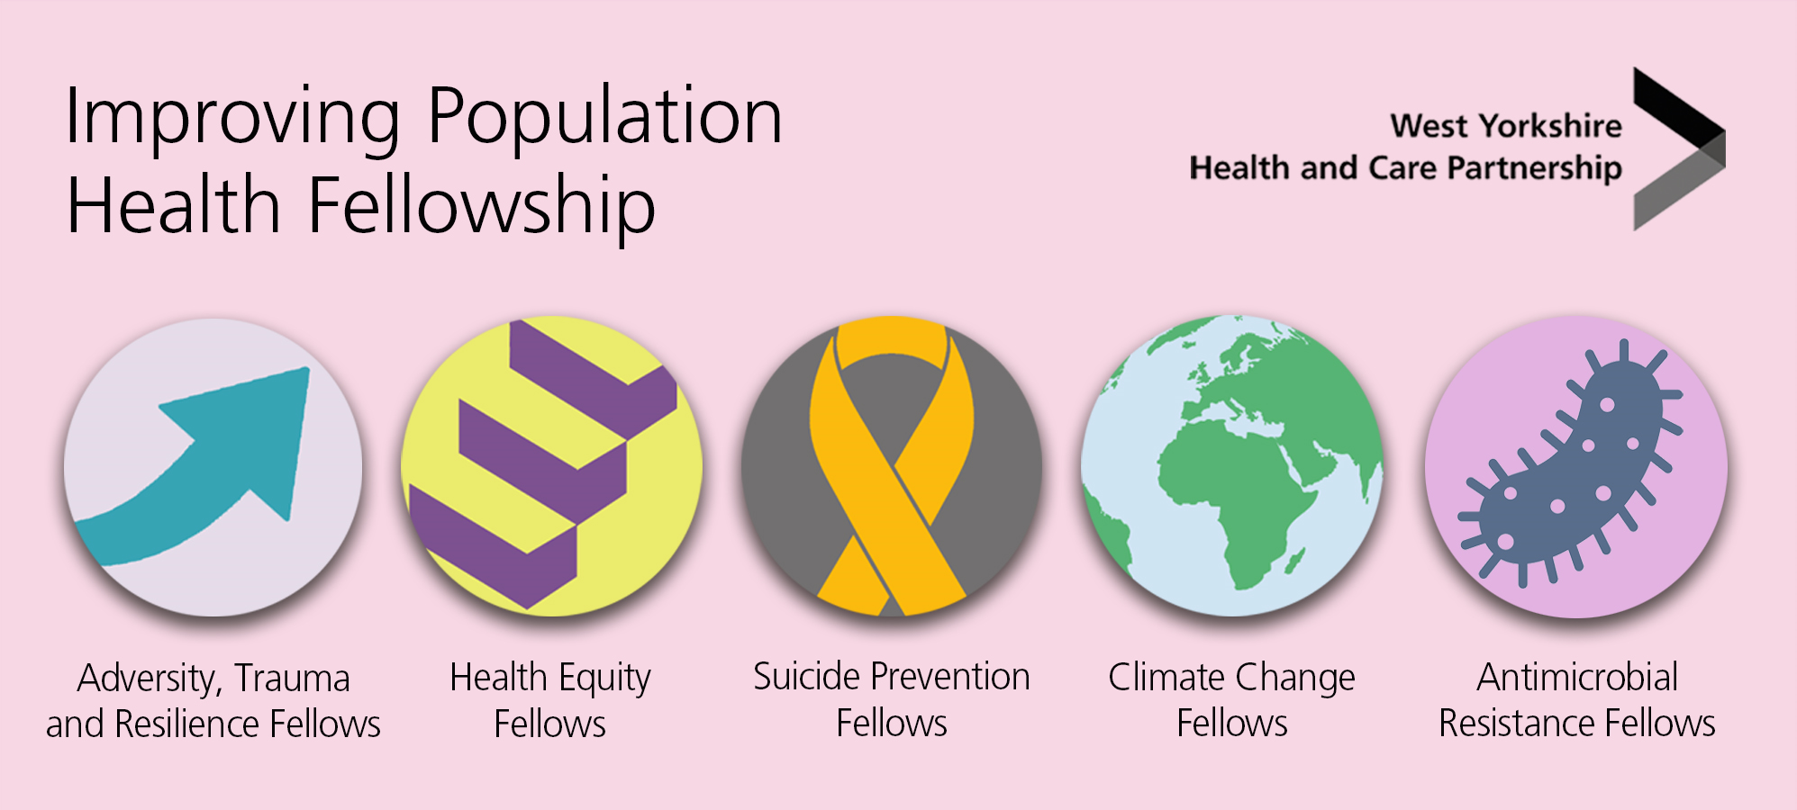



To apply for one of the Improving Population Health Fellowship programmes, please complete and return this statement of interest to [iphp.fellowshipenquiries@nhs.net](mailto:iphp.fellowshipenquiries@nhs.net)

|  |
| --- |
| **Who should apply?** |
| The Improving Population Health Fellowship is open to colleagues from all sectors including health, social care, local authority, voluntary and community services across West Yorkshire irrespective of your current job role, grade, or profession.  You will need to:   * be passionate about your specialist area of choice * want to become a champion and achieve change * be committed to the delivery of a fellowship project * agree to carry out formal learning as part of the fellowship * confirm prior support from your current organisation that you will have protected time to take part fully in the fellowship   The Improving Population Health Fellowship is designed to bring together the diverse organisations and professionals that influence health and wellbeing and attract applicants that are representative of the communities we serve. There are no specific educational requirements or preferred professions. |
| **Selection criteria** |
| We will select fellows based on demonstrated commitment to your specialist area of choice. A selection panel will score the expressions of interest against the following selection criteria, which you’ll need to demonstrate through this form.   * Strength of statement of interest, including personal motivation, commitment to your chosen area, application in the workplace and continued application of learning following the fellowship * Quality of proposed project * Confirmation of support from your line manager   We will also seek to recruit fellows from across West Yorkshire that reflect both a variety of professional backgrounds and are representative of the communities we serve. |
| **Demographics**  Your personal information will only be used for the purpose of contacting you regarding your application. We will not share this information with any third parties |
| Name: |
| Contact email: |
| Job title: |
| Current employer: |
| Location: |
| Ethnicity: |
| Do you have any accessibility needs? |
| **Specialist area of choice**  Please indicate below which fellowship programme you are applying for (delete as necessary) |
| * Health Equity * Adversity Trauma and Resilience * Climate Change * Suicide Prevention * Antimicrobial Resistance |
| **Statement of interest** |
| 1. Please write a brief statement about yourself and your personal motivation for applying for the fellowship (no more than 250 words) |
|  |
| 1. Please provide an overview of the current challenges related to your specialist area of choice that you see in your current role and how you would seek to expand your learning and experience to address these through the fellowship (no more than 250 words) |
|  |
| 1. Please describe any existing experience and contributions to date in your specialist area of choice, either through work or through community or volunteer service, and how they will contribute to your fellowship experience (no more than 250 words) |
|  |
| Please provide an overview of how you plan to continue to develop your knowledge and skills relating to your specialist area of choice beyond completion of the fellowship (no more than 250 words) |
|  |
| **Project proposal**  Please describe one project you would like to complete during the fellowship term. The project should focus on a topic that is aligned with your specialist area of choice (health equity; adversity, trauma and resilience; climate change; suicide prevention; antimicrobial resistance), and issues that you and/or your organisation focus on. The project is a key part of the overall learning and should include the following:   * description of project idea/chosen project * the difference it will make to your organisation * what you think success could look like * how the learning from your project could be shared (no more than 400 words) |
| **Description of project idea/chosen project**   1. Establish a formal research project to enable critical evaluation of the Seeking Safety treatment within NHS secondary mental health care. 2. Develop a Seeking Safety pathway within SWYT as part of our commitment to trauma-informed practice. 3. Work alongside Trauma Informed Personality Disorder pathway to broaden scope of the service offer for clients with CPTSD. 4. Provide treatment, staff training, supervision, and training materials into other BDUs. 5. Work with SPA to identify criteria for direct referral into the Seeking Safety treatment group. 6. Collaborate with psychiatry to further develop understanding of medication which enables improved therapy outcomes in the Seeking Safety group.   **The difference it will make to your organisation**  *Summary of benefits:*   * More clients will receive service. * Client flow through service will improve. * Caseload blocking will be relieved. * Client time in psychological therapy will reduce. * Psychology waiting list pressure will reduce.   **What you think success could look like**  To increase awareness and understanding of the benefits the seeking safety treatment can offer for both clients and services, and to generate interest in accessing training with the view to delivering the Seeking Safety treatment to their own population of clients.  **How the learning from your project could be shared**   * Conferences – professional and research-based * Online presentations * Publication * Research dissemination |
| **Programme expectation** |
| The Improving Population Health Fellowship will run between 1 April 2025 and 31 March 2026.  You will be expected to:   * commit to one day a week to work on a fellowship project. This will include independent project work, monthly meetings with your mentor and submission of an interim and final project report in a format of your choice. * participate in the Foundation Programme in Public Health – this will be 4 x 3 hour sessions over a period of approximately six months. * Attend additional trainings and face-to-face events organised through the fellowship.   **Please note, if you are working in a voluntary or community sector organisation, funding may be available to support backfill for Improving Population Health Fellows.** |
| **Line manager support** |
| Line manager name: |
| Line manager role: |
| Line manager organisation: |
| I understand the time commitment expected of the named applicant to undertake the Improving Population Health Fellowship and I agree to support the applicant with the time required to as part of their role.  **Signed:**  **Name:**  **Date:** |

